Supplementary Information: 32-Channel Microfluidic Controller Assembly

This section of the Supplementary Information provides detailed instructions for the fabrication of the 32-channel microfluidic controller. The controller uses miniature pneumatic solenoid valves (The Lee Company, Westbrook, CT, USA) to latch/unlatch the elastomeric control valves in multilayer poly(dimethylsiloxane) (PDMS) microfluidic chips under the control of a low cost open-source programmable microprocessor card (Arduino Mega 2560). The Arduino is programmed with microfluidic biological protocols, uploaded to the card via USB, automating the valving on the microfluidic chip to perform nanoliter scale operations of benchtop protocols such as mixing, storage and incubation of fluids. A liquid crystal display provides a text-based interface for the user to step through the biological protocol run on the microfluidic chip using a button on the front panel of the hardware. All parts are suggested and were used to make the prototype controller (Fig S1).

The instructions are broken down into sequential sections to assemble the controller. A parts list for each section is provided, based on the assembly of the prototype used to automate the synthetic biology protocols on chip as reported in the letter. All listed parts are manufacturer part numbers. In many cases, lower cost equivalents may be substituted. The project was initially done in breadboard format to make it accessible to the broadest user base.

**I. Box Housing**

A sheet metal box was used as the housing for the microfluidic controller. The box was pre-drilled and machined in our laboratory, providing holes for both mounting hardware and pass–through holes for pneumatic tubing.

*Parts Needed*

(12” (l) x 7”(w) x 4” (h)) (0.040” (t)) aluminum sheet metal box (Hammond 1411XU or equivalent) *This size allows efficient packing of the components in the box without being too cramped to make assembly difficult)*

14 Push-in locking grommets ½” ID 5/8” panel hole (McMaster Carr, 5269T161)

*Box Machining Schematics*

A set of drawings for machining the holes and cutouts in the box is shown in Fig S2.

After machining, push the locking grommets into the 5/8” panel holes.

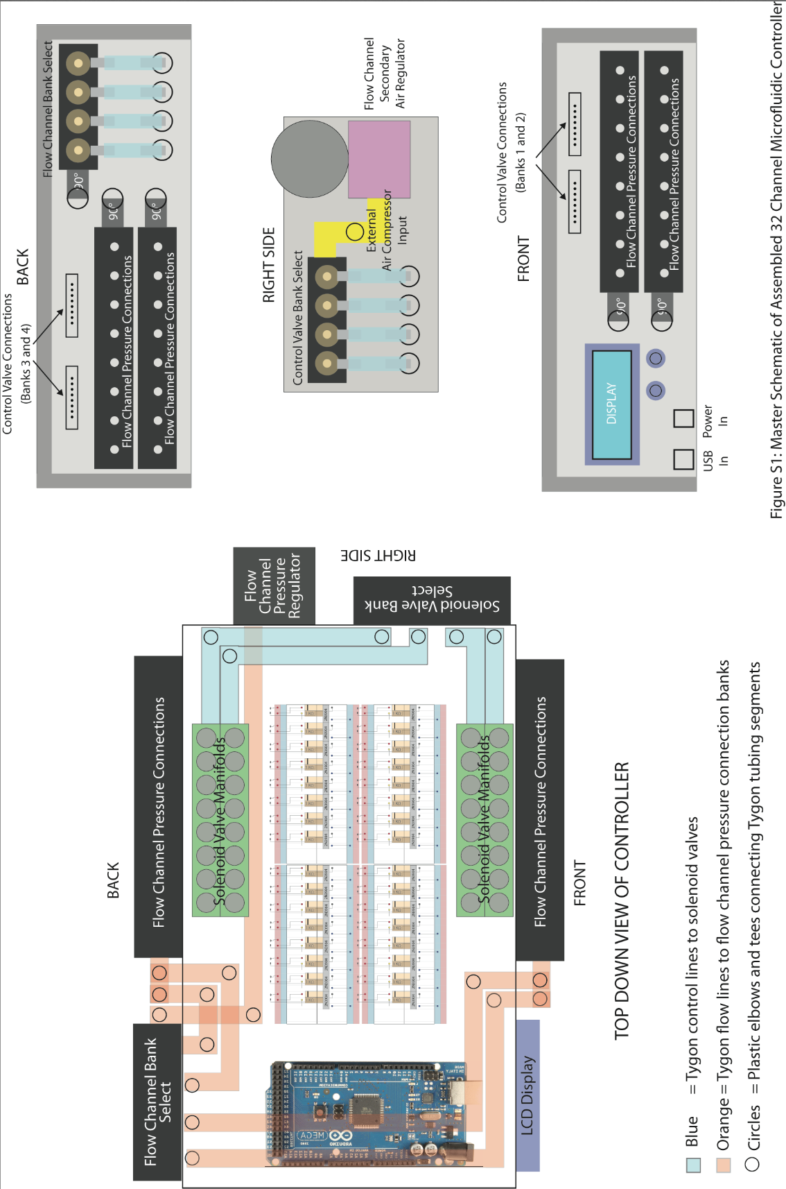

**Supplementary Figure 1** Master schematic of 32-channel (4 x 8 valve array) microfluidic controller.

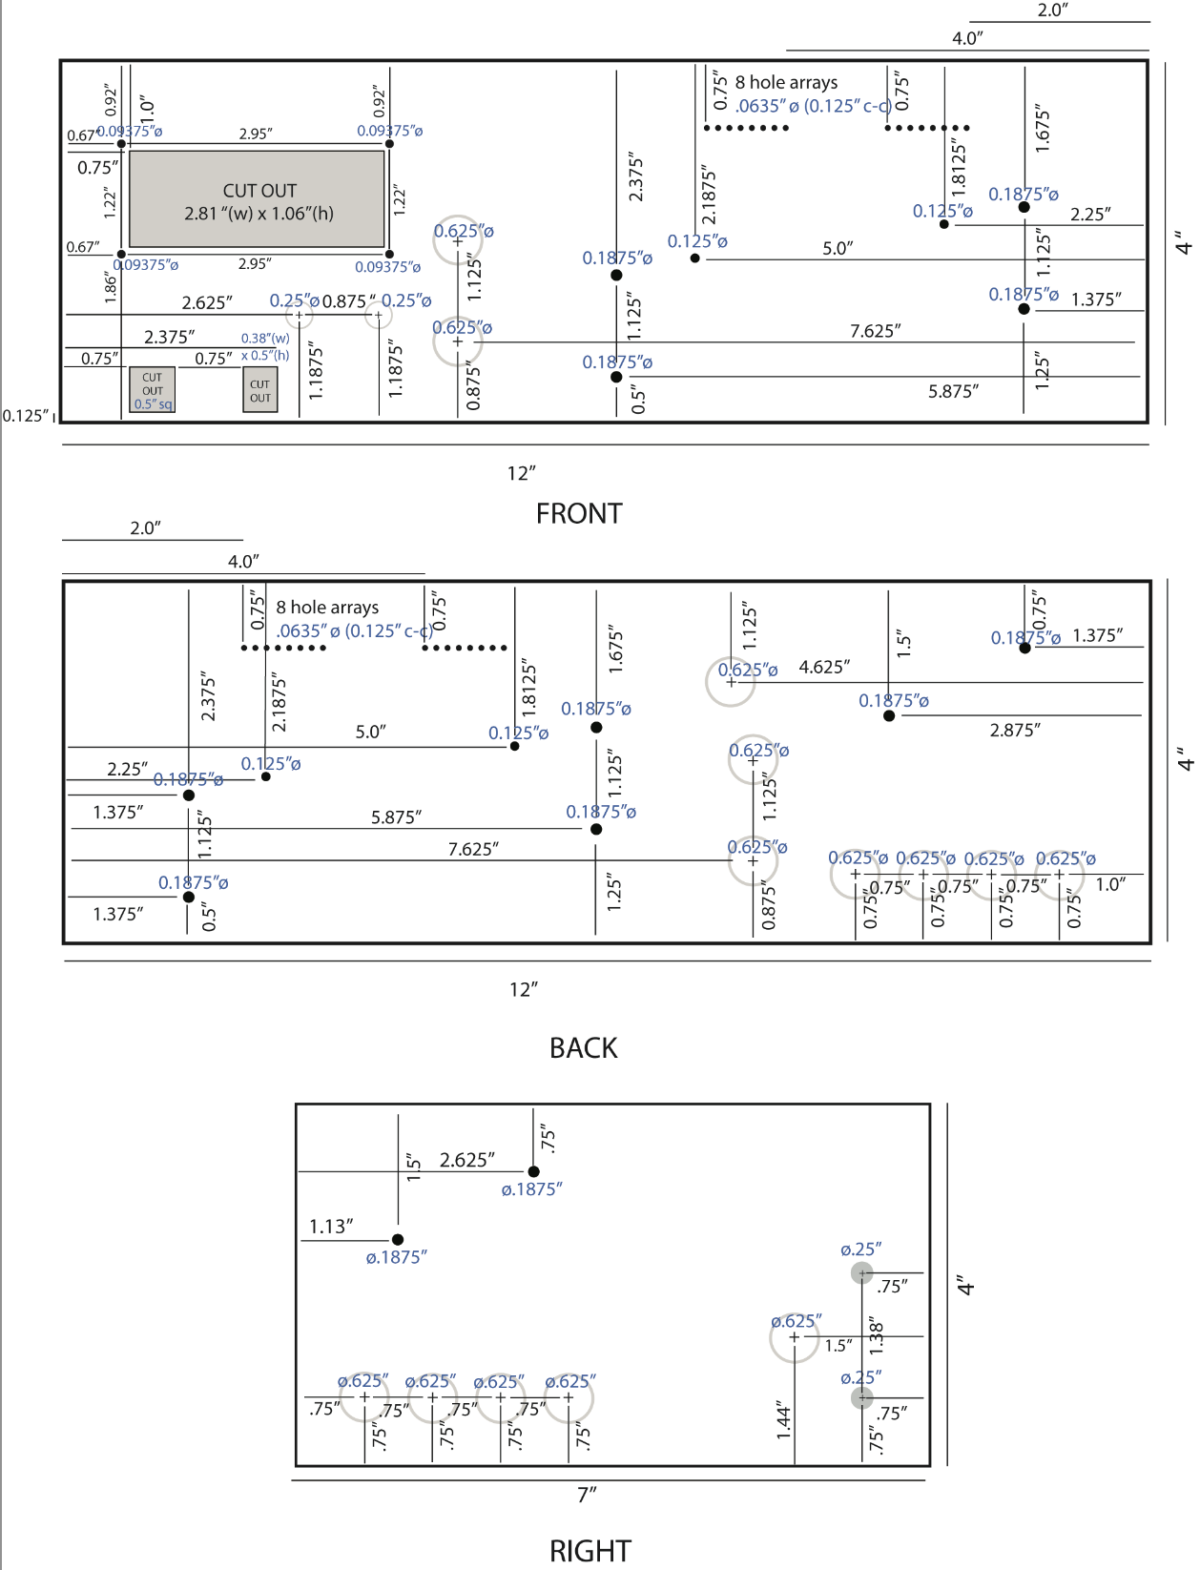

**Supplementary Figure 2** Hole and cutout schematic for the aluminum microfluidic controller box.

**II. Valve Switch Breadboard**

To power the solenoid valves (+12V) from the digital output from the Arduino board (+5V), simple valve switch circuits are implemented. The digital output from the pins on the Arduino board toggle the off/on state of the solenoid valves, which are powered by a 12V AC adapter. While a breadboard was used for the prototype, the switch array can be made as a printed circuit board, either as a stand alone part, or as a shield for the Arduino.

*Parts needed*

- 4 small solderless breadboards (Twin Industries TW-E40-510) (one for each bank of 8 valves)

- 8 NPN transistors (2N3904)

- 8 diodes (IN4001)

- 8 resistors (1KΩ, 1/6 W, +/- 5%)

- Solid core wire for breadboard interconnects

*Assembly*

Populate each breadboard with components as shown in Fig S3. The figure shows a single populated breadboard to control eight solenoid pneumatic valves on a single breadboard. The inset shows a representative circuit of each switch. The connection of the valves and the power source/ground are described later in the protocol. *+5V refers to the the digital signal input from the Arduino control pins assigned to the respective valves (connected in Section III).

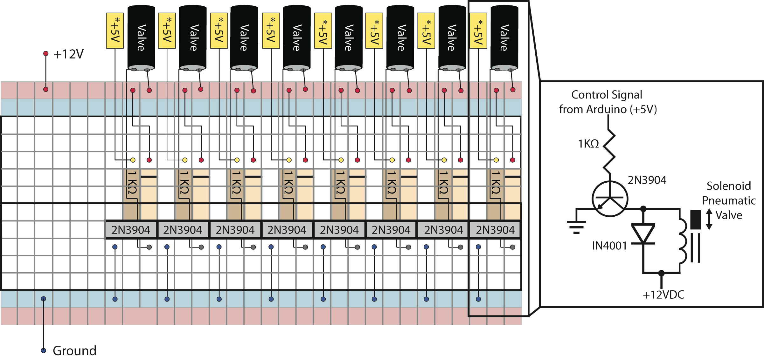

­

**Supplementary Figure 3** Breadboard array of eight pneumatic valve control switches (inset –representative single switch circuit).

**III. Arduino/Valve Switch Mounting and Wiring**

In this section, the Arduino Mega 2560 and the valve switch breadboards are mounted in the bottom of the inside of the aluminum box enclosure and the valve switches are wired to the digital I/O pins of the Arduino. Mini breadboards used in this project like those from Twin Industries have adhesive foam backing on the reverse side that make it easy to secure on the floor of the box. The Arduino can be mounted using double sticky foam tape or four 4-40 x ½” screws. It in important that the bottom of the Arduino is not in direct contact with the sheet metal to avoid shorting, so, when using screws, insert a piece of electrically insulating material under the board like foam or rubber. We mounted the board using screws and used cut pieces of Tygon tubing under the board as standoff material.

*Parts needed*

- Machined aluminum box (Section I)

- Four populated valve switch breadboards (Section II)

- Arduino Mega 2560 board

- Roll of 22 AWG solid core wire

- Four pan head 4-40 x ½” screws and nuts or double sticky foam tape

*Assembly*

The Arduino Mega is mounted inside of the box in the front left corner (Fig S1). The power and USB ports of the board should be lined up so that they slightly protrude through the small square cutouts shown in the front perspective diagram of Fig S2. The valve switch breadboards are mounted in the relative positions shown in Fig S1. The absolute positions of the breadboards are not important, but they should be centered to allow space for subsequent wiring and hardware routing.

A pinout key for the Arduino Mega is shown in Fig S4. In this section, we will be connecting lengths of solid core wire between the Arduino digital I/O pins, broken up by the solenoids valve bank that they control, and the valve switch breadboards, with interfacing with the other described pinouts described in subsequent sections. To connect the pinouts, cut sections of 22 AWG solid core wire are used, stripping ¼” of the casing off of both ends to pride good electrical conduct upon insertion into the breadboard holes and the Arduino pinouts. Each set of solenoid bank pinouts shown in Fig S4 connects to a single valve switch breadboard. The digital I/O pins of the Arduino are connected to the respective 1kΩ resistors on the breadboards represented as +5V inputs in Fig S3. The connection map is shown in Fig S5, with each Arduino pin connecting to a unique switch circuit on the respective boards.

Finally, the power and ground columns on the breadboards are wired to the Arduino. +12V columns on the breadboards are tied and connected to Vin on the Arduino through a single wire. Wiring up the grounds is accomplished in the same manner.

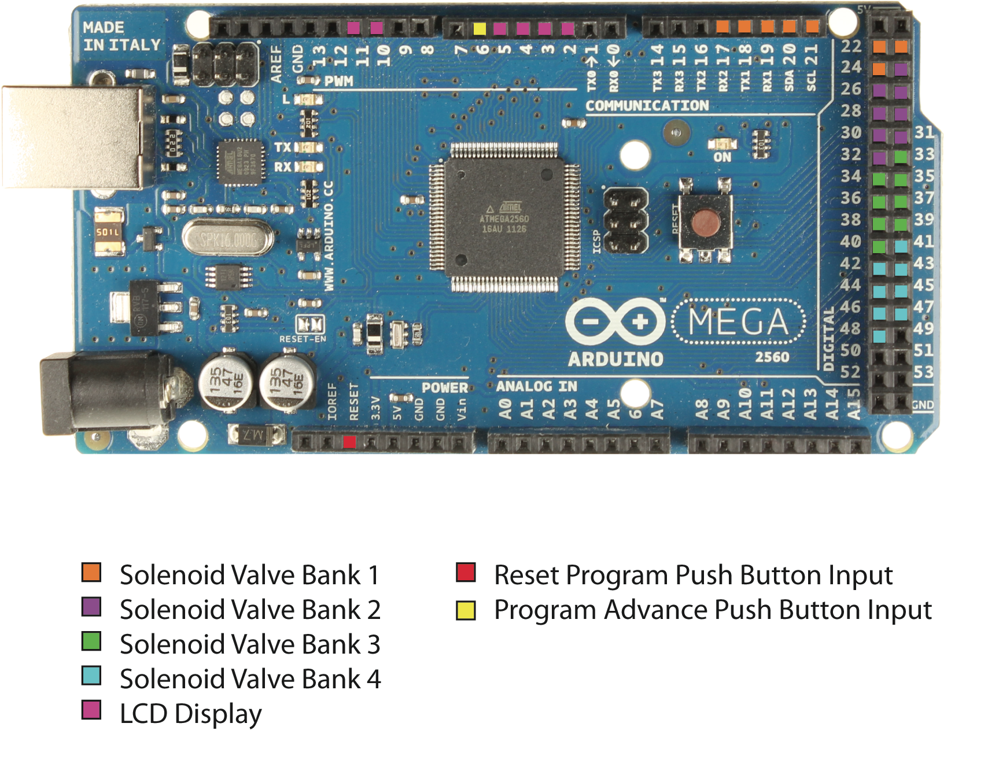

**Supplementary Figure 4** Microfluidic controller wiring connections for the Arduino Mega 2560.

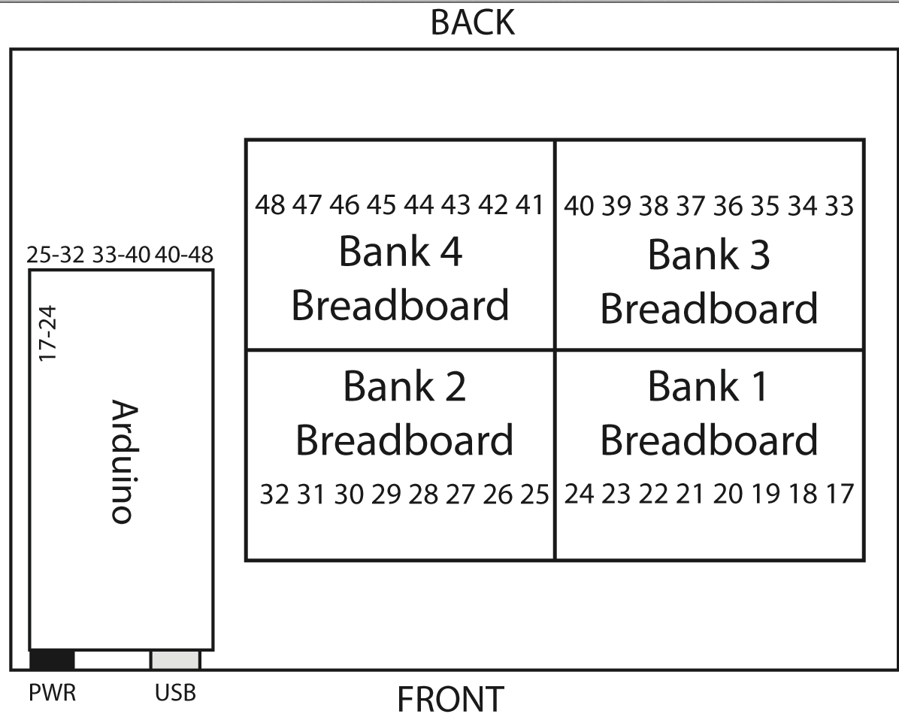

**Supplementary Figure 5** Wiring interface diagram between the Arduino Mega 2560 digital I/O and the valve switch breadboards. The sequential numbering on the breadboards maps the wired connection on each circuit to the digital I/O pins on the Arduino.

**IV. Liquid Crystal Display/Push Button Wiring and Interfacing with the Arduino**

In this section, a 16 x 2 character backlit liquid crystal display (LCD) is added to the box to enable the end user with a text interface to visually step through pre-programmed biological protocols. Two interface buttons are used for this purpose, one to manually advance the protocol (i.e. after a long incubation on a microfluidic chip run by the controller) and one to reset the Arduino, returning the uploaded protocol to its initial command state.

In this section, the LCD and the pushbutton switches are wired to the Arduino.

*Parts Needed*

- Soldering iron

- Solder

- 22 AWG solid core wire

- Two miniature single pull single throw normally open (SPST-NO) pushbutton switches, 3A 125V (Lots of suppliers, we chose red and black button switches (red for reset, black to advance protocol) from CW Industries (Southampton, PA, USA) and E-Switch (Minneapolis, MN, USA) (Part numbers GPB024A05BR and SP1024ABLK)

- 16 x 2 backlit LCD display (Lots of suppliers produce these inexpensive displays. Only restriction is that the driver on the LCD must be Hitachi HD44780-based to work with the Arduino Liquid Crystal software library). For this prototype, a 5V backlit blue/white letter 16 x 2 made by Newhaven Display (Elgin, IL USA) was used (Part number NHD-0216K1Z-NSW-BBW-L) .

- 10kΩ potentiostat 0.25W

- Four pan head 2-56 x ½” screws and nuts

*Assembly*

22AWG wire is soldered to the pads on the LCD and wired to the respective pins on the Arduino as shown in Fig S6A. Additionally, the unused power column on Bank 2 Breadboard is tied to the 5V pin on the Arduino to drive the liquid crystal display and enable brightness control adjustment through a 10 kΩ potentiostat. Connection of the potentiostat and +5V to the Bank 2 Breadboard is shown in Fig S6B.

The wire up the pushbutton switches, 22AWG wire is soldered to the contact pads. One lead of the red pushbutton switch (reset) is connected to the reset pin on the Arduino and the other is connected to the common ground column on Bank 2 breadboard. For the program advance pushbutton, one lead is connect to pin 6 on the Arduino and the other is also connected to the ground column on the Bank 2 breadboard. Mount the wired LCD and buttons as shown in Fig S7. The LCD is mounted with the screen projected out of the front face of the box with four 2-56 screws while the pushbutton switches are pre-threaded, and mount by removing the front nut, pushing the button end of the switches through the pre-drilled holes on the front face of the box, and securing them by re-tightening the nuts on the front face.

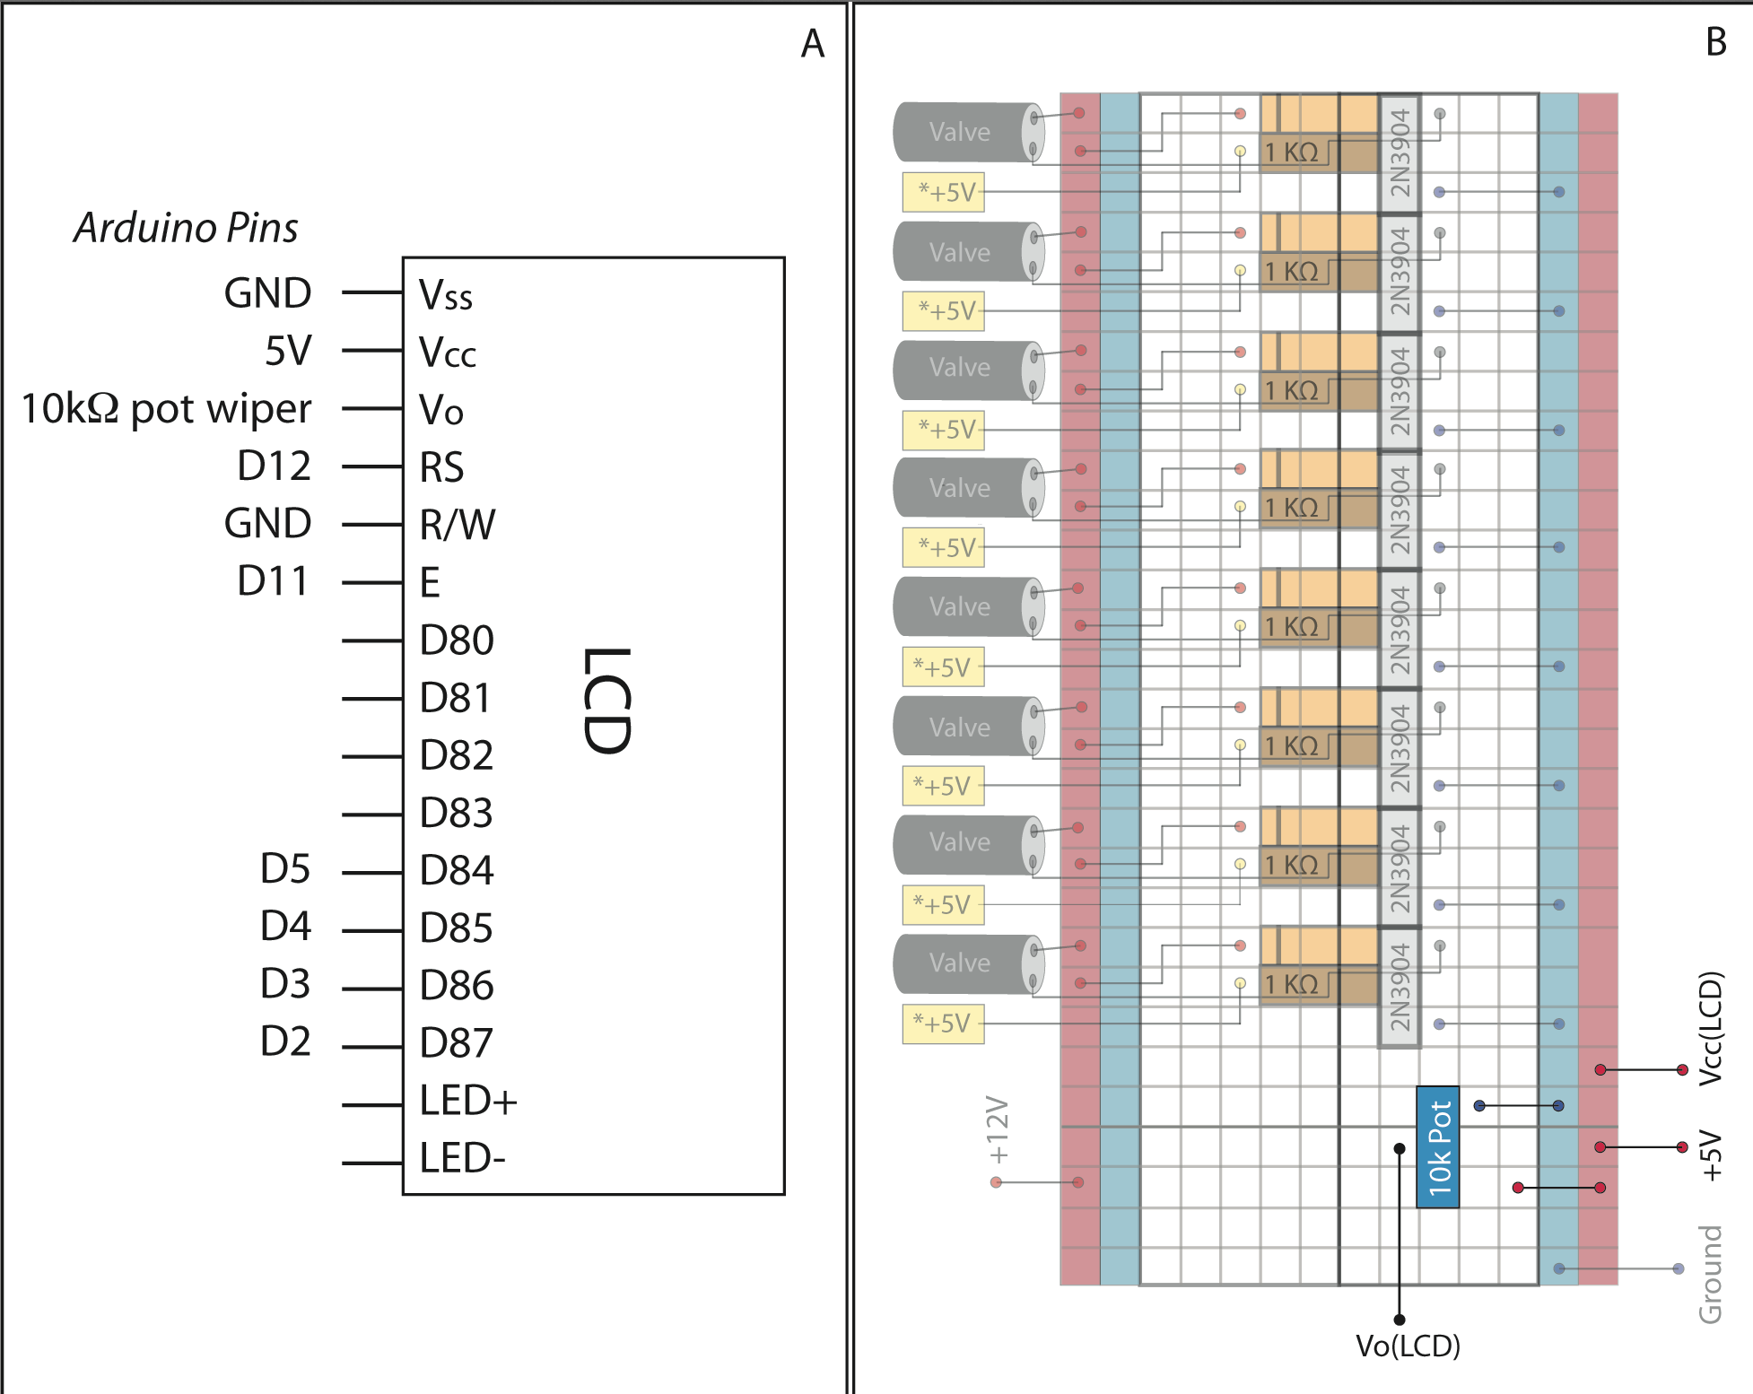

**Supplementary Figure 6** (**a**) Wiring between the LCD and the Arduino, with the exception of the LCD pins Vo and Vcc, which are wired to the Bank 2 breadboard. (**b**) Bank 2 breadboard connections for the LCD, 10Ω pot and +5V (wired to Arduino 5V pin).

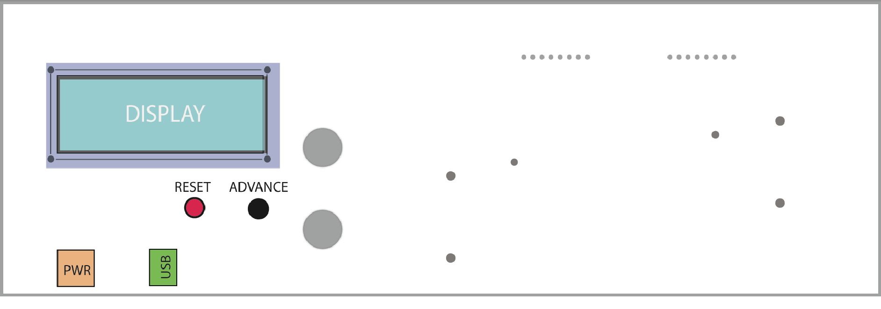

**Supplementary Figure 7** Front of controller box after installation of LCD and push buttons.

**V. Solenoid Valve Bank Assembly and Case Mounting**

In this section, manifolds of eight miniature pneumatic solenoid valves are assembled on manifolds, with wire leads soldered on the electrical interconnect pins to interface with the valve switch breadboards. Valve mounting and case mounting of the assembled manifolds is detailed.

*Parts Needed*

- Soldering iron

- Solder

- 22 AWG solid core wire

- 4 8 valve manifolds (The Lee Company, LFMX0510538B)

- 32 High Density Interface (HDI) 3-way solenoid valves 12V 15psi (The Lee Company, LHDA1221111H)

- 36 2-56 x 7/16 pan head screws

- 4 4-40 x 1” pan head screws plus 12 nuts

*Assembly*

The solenoid valve manifolds are mounted in a stacked configuration on the inside of the front and back panels of the case as shown in Fig S8. The mounting holes as provided from the vendor are too small for a substantial machine screw to support the manifolds. Consequently, they are drilled out with a 1/8” diameter bit, large enough for 4-40 x 1” screws.

Next, taking one solenoid valve, align the pneumatic face (with the three ports) as shown in Fig S8, and, using two 2-56 screws, gently tighten to the point where the valve is flush with the manifold. Repeat for the remaining valves on the four manifolds.

Solder ~6” segments of 22AWG wire to the two electrical contact of each valve and assemble and mount the manifold stack as follows. For each two manifold stack, thread the 4-40 screws through the mounting holes of one of the manifolds. Tighten two bolts to the backside of each manifold to make a spacer, then thread the second manifold on to the ends of the bolts as shown in Fig S8A. The valve arrays will face the case wall, rather than the inside of the case. Finally, mount the assembled manifolds on the insides of the case at the positions shown in Fig S8B.

To wire the valves on the manifolds to the valve switch breadboards, work from right to left on each manifold, wiring the first soldered lead of each valve to the collector transistor pin on the switch and the second to ground. Start from the inside manifold nearest to the case for each manifold set (connecting to Bank 2 breadboard (front inside manifolds set) or Bank 4 (back inside manifold set), followed by the outer manifolds, connecting to Bank 1 (front) and Bank 4 (back) breadboards respectively. For breadboard wire placement, refer to Figs S3 and S5. For example, Solenoid valve 1 on manifold 1 should connect to the switch that is wired to Arduino pin 17, wiring up the valves in order on the manifold so that solenoid valve 8 on manifold 1 connects to the switch that is wired to Arduino pin 24. Repeat for all four manifolds.

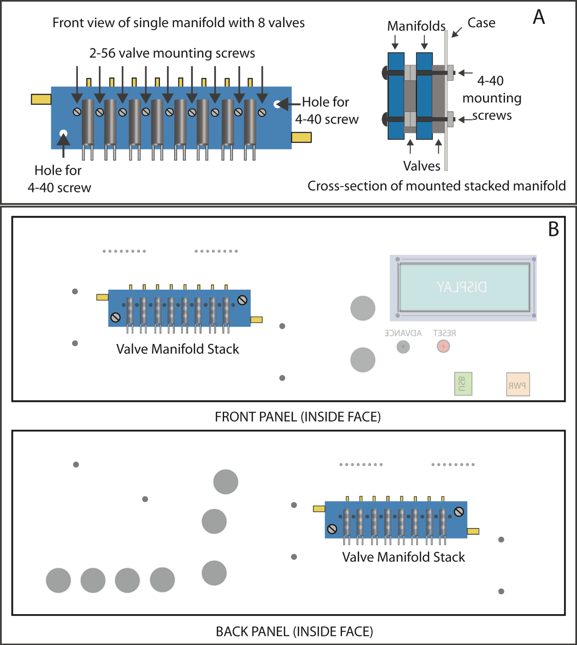

**Supplementary Figure 8** (**a**) Front view of 8 valve manifold assembly and cross-section of stack of two manifolds mounted on the inside of the case. (**b**) Mounting positions for the front and back panel manifold stacks.

**VI. External Pneumatic Hardware Assembly**

The pneumatic hardware for the microfluidic controller consists of a low cost airbrush pneumatic air compressor to provide air pressure, a secondary regulator to step down the pressure for driving liquids through the flow channels and supporting external manifolds, and Tygon tubing for the pneumatic interconnects.

*Parts Needed*

4 Inline Manifold Aluminum 1” sq ¼”npt in 8 x 1/8” npt out (Pneumadyne, M10-125-8)

2 Inline Manifold Aluminum 1” sq ¼”npt in 4 x 1/8” npt out (Pneumadyne, M10-125-4)

8 1/8” NPT M to 10-32 F Manual brass toggle valves (Clippard, TV-2MP)

1 0-10 psig mini regulator (Marsh Bellofram) 1/8” npt (Cole Parmer, EW-68826-46)

1 0-15 psig utility pressure gauge 1/8” npt (Cole Parmer, EW-68355-18)

32 Adapter (Male luer to 1/8 27) (Cole Parmer, YO-45505-86)

32 Female Luer Caps (Cole Parmer, SI-45500-28)

100 ft roll Tygon tubing (1/8” ID x 1/4” OD)(Cole Parmer, EW-95631-05)

1 1/8” polyethylene tube tee (McMaster Carr, 2808K166)

12 1/8” polyethylene 90° elbows (McMaster Carr, 2808K115)

8 Nylon single barb 90° fitting 1/8”tube ¼” pipe (McMaster Carr, 2974K152)

2 Nylon single barb for 1/8" Tube X 1/8" NPT Male (McMaster Carr, 2974K142)

8 1/8” tube ID x 10-32 UNF male nylon tube fitting (McMaster Carr, 2974K117)

1/4” hex head polypropylene plug (McMaster Carr, 4515K209)

12 8-32 x 1” pan head screws and nuts

2 8-32 x ¼” pan head screws plus washers and nuts

½” Teflon tape

1/8 Horsepower, 40 PSI Oil-less Airbrush Compressor (Harbor Freight, SKU 93657)

*Assembly*

The short 4” manifolds are used to turn on/off air pressure to the control solenoid banks and the 8” manifolds, which provide constant pressure to the flow lines. To each 4” manifold, screw in four brass toggle valves to the four 1/8” npt holes on the front face as shown in Fig S9A. Use a bit of Teflon tape around the threads on all threaded connections. Next, add a 1/4” polypropylene plug to one end of each manifold and a Nylon single barb 90° fitting to the other end. Orienting the part facing the brass valves, one 4”manifold is assembled with the plug on the left side and the 90° barb facing out, while, in the other part, the plug is placed on the right side, with the 90° barb facing inward on the left side. Finally, add male nylon tube fittings to the 10-32 ports on the side of each brass valve, making sure the fittings all point in the same direction after assembly. For the 8” manifolds, the male luer adapters are threaded into the 1/8” ports on the front face of the part, followed by the addition of the female luer caps to the luer adapters. Like the 4” manifolds, polypropylene plugs are added to one end of the manifold and a 90° Nylon barb is added to the other. Assemble two 8” manifolds (orienting the part with the luer assembly facing forward) with the ports on the left and the 90° barbs on the right, and the other two manifolds with the opposite port/barb configuration. For all manifolds, the barb should face inward. These 8” manifolds provide an easy interconnect for constant pressure flow lines, enabling the end user to swap out one of the female caps with a luer stub adapter attached to microbore tubing filled with the reagent of interest to be added to a microfluidic device.

Mount the manifolds and flow channel regulator on the external faces of the microfluidic controller box as shown in Supplementary Figure 9(b). Coupling barbs that face into the box are designated as an [x] on the figure, while outward facing ones are labeled as [o]. 8-32 x 1” machine screws are used to fasten the manifolds to their respective positions on the box, using nuts to secure them on the external faces of the box. The flow channel regulator is mounted using 8-32 x ¼” screws on the right external face using the supplied mounting bracket. Prior to mounting the regulator, attach the pressure gauge and straight nylon single barb adapters to the inlet and outlet. When mounting the regulator, the barbs should be oriented such that one barb passes through the large pre-machined hole on the box face and the other faces outward.

After the manifolds and regulator are attached, cut sections of Tygon tubing (1/8” ID x ¼” OD) are used to make the external pneumatic interconnects. Using a razor blade, cut the tubing segments to size. Each small (4”) manifold will need 4 ~2” segments, which attach to the brass valve outputs. At the other ends of these segments, attach 90° polyethylene elbows, which should be oriented so that the non-attached barbs face into the box through the holes as shown. For the small manifold, attach a ~3” segment of tubing to the Nylon barb on the end of the manifold. Connect the free end of this segment to a polyethylene tee. To the section of the tee normal to this connection, attach a 3’ section of tubing. Connect this long run of tubing to the pneumatic air compressor used to pressurize the box. Finally, use a 3” segment of tubing to connect the remaining barb on the tee to the outward facing barb on the flow line regulator.

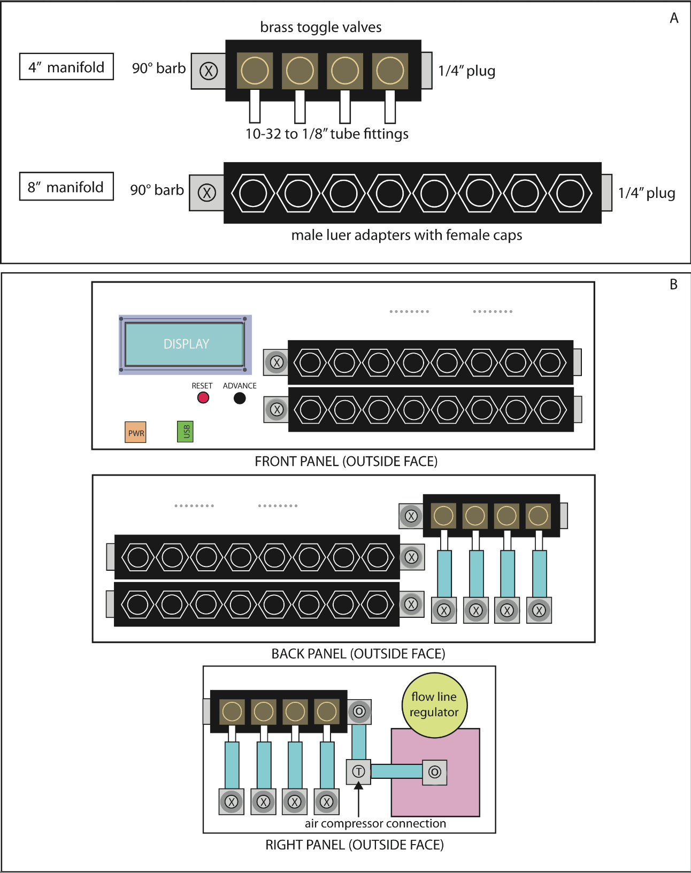

**Supplementary Figure 9** (**a**) Assembly detail for the toggle switched (4”) and flow line (8”) manifolds. (**b**) Schematic showing the placement of the manifold, regulator and external pneumatic tubing.

**VII. Internal Pneumatic Hardware Assembly**

To finish the assembly of the microfluidic controller, the final step is to complete the Tygon pneumatic interconnects inside of the box, connecting the solenoid valve banks to the brass valve regulated 4” manifold on the right face of the box, and the constant pressure 8” flow manifolds to the brass valve regulated 4” manifold on the back face of the box.

*Parts Needed*

50 ft roll Tygon tubing (1/32” ID x 3/32” OD)(Cole Parmer, EW-64007-70)

100 ft roll Tygon microbore tubing (0.20"ID x 0.60" OD) (Cole Parmer, EW-06418-02)

100 ft roll Tygon tubing (1/8” ID x 1/4” OD)(Cole Parmer, EW-95631-05)

12 1/8” polyethylene 90° elbows (McMaster Carr, 2808K115)

used to as interconnect pieces to couple the microline to the valve ports (array of 8 on the top face of each manifold. Cut 16 ~1/2” lengths of 1/32” Tygon tubing and stretch them out to fit over the ports. To connect the microline, wrap each piece in

*Assembly*

Using Supplementary Figure 10 as a guide, connect segments of 1/8” ID x 1/4” OD Tygon to the respective 1/8” barb connections. Polyethylene elbows are added to Tygon segments inside of the box to improve the layout and allow accessibility to components like the breadboards for future upgrades.

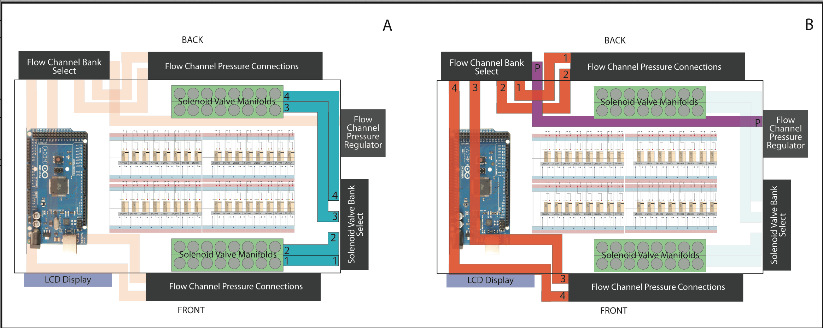

**Supplementary Figure 10** Internal pneumatic connections in microfluidic controller; (**a**) Tygon interconnects (blue) between the external solenoid valve select bank manifold and the four solenoid valve arrays. (**b**) Tygon interconnect (purple) between the flow like regulator and the flow channel bank select, and the Tygon interconnects (orange) between the flow channel bank select and the four flow channel pressure connection manifolds.

Finally, connect the microline tubing to the solenoid valve manifold ports. As the microline tubing (which connects to the microfluidic devices) is smaller (.060” ID) that the Lee solenoid valve manifold ports (.300” ID), small segments of 1/32” ID Tygon are

used to as interconnect pieces to couple the microline to the valve ports (array of 8 on the top face of each manifold. Cut 16 ~1/2” lengths of 1/32” Tygon tubing and stretch them out to fit over the ports. To connect the microline, cut 16 ~12” segments, wrap one end of each piece in in one layer of Teflon tape (to make a snug fit for the coupling) and insert into the free end of each 1/32” Tygon coupling segment on the two solenoid manifold. After attaching the microline, pass the free ends out the control valve connection holes shown in Fig S1. Take care to thread them through in sequence, i.e. the microline coming out the far left control valve hole of bank 1 on the box corresponds to the solenoid valve connected to the lowest pin on the Arduino (Supplementary Fig. 5). Repeat for all four solenoid valve manifolds.

The box is now fully assembled and operational, pending programming of the Arduino and connection of the microfluidic device to the control valve and constant flow pressure lines. To interface the controller with a microfluidic device, the tubing from the control line outputs on the controller box are connected to the corresponding inputs on a microfluidic chip, followed by the connection of the constant pressure flow line tubing. To interface the control lines, additional segments of microline tubing (typically 1 – 2 feet in length, depending on how close the controller is positioned relative to the chip) are connected to the microline segments coming out of the control line connection banks, using 23G stainless steel pins as interconnects (0.3” length, New England Small Tube, Litchfield, NH, USA). Additional steel pins are added to the open ends of each microline segment, which fit into the punched control line ports on the microfluidic chips. These additional segments of control line tubing are filled with deionized water to dead end fill the control valves with water during the valve priming process, as the trapped air in the microfluidic valves naturally outgases under pressure through the gas-permeable PDMS rubber. When operated, the pressurized air in corresponding control lines coming out of the controller pushes the primed water in the added control line segments like a piston, opening and closing the water-filled microfluidic valves without injecting air into the flow channels. To connect the flow lines, the female caps on the flow manifolds are removed (one for each flow line to be interfaced with the micrcofluidic chip), replaced with 23G blunt end stainless steel needles with polypropylene luer interconnects (Part # 75165A684, McMaster Carr). For each flow line interconnect, a segment of microline tubing (1-2 feet) is connected to the needle and the other end of the tubing, which connects to the corresponding flow input on the microfluidic chip, is fitted with a 23G stainless pin. Prior to connecting the flow line assembly to the box, the flow line reagent is drawn up a few cm into the flow line using a disposable syringe. With the flow line manifold toggle switches set to off (no pressure), connect the flow line assemblies to the flow manifolds on the controller followed by the chip. The flow line pressure toggle valves typically are opened (pressure on) only after all of the control valves on the chip are primed, depending on the program to be run, with the flow regulator set to a maximum of 3-4 psig lower than the control valve pressure (set on the air compressor regulator). A sample program for automated microfluidic genetic assembly is provided as additional supplementary material.